**Quest Specialty Lab Acute Care Orders from Cerner Requirements**

**Version 1.1**

**Prepared By: Sarah Thies & Art Schwartz**

**Date: 5/24/2017**

Document Control 3

Resources 3

Project Distribution List 3

Document Version Control 3

1. Introduction 4

1.1 Purpose 4

1.2 Project Scope 4

1.3 Terminology Standards 4

1.3.1 Acronyms 4

1.3.2 Glossary 4

1.4 Document References 4

2. Diagram 5

3. Requirements 6

3.1 Functional Requirements (Cerner FSI) 6

3.2 Non-Functional Requirements 6

3.3 Messaging Protocols 6

3.3.1 Inbound to the BayCare Cloverleaf 6

3.3.2 Outbound to the BayCare Cloverleaf 6

3.3.3 Inbound to the Vendor 7

3.3.4 Outbound to the Vendor 7

3.3.5 Inbound to the BayCare Cerner EMR 7

3.3.6 Outbound BayCare Cerner to Cloverleaf 8

4. HL7 Messaging 9

4.1 Messaging Format 9

4.1.1 Segments 9

4.1*.*2 Messaging Event Types 9

4.1*.*3 Cloverleaf Configuration Files 10

4.1.4 Cloverleaf Site Location 10

4.2 Data Transformation Requirements 10

4.3 Sample Messages 11

5. Testing 15

5.1. Unit Testing Scenarios 15

5.2 Integrated Testing Scenarios 15

5.3 Testing Approvals 15

5.4 Piloting 16

5.5 Approvals - Please see Monica Bousbar in the Lab 16

6. Deployment / Implementation Model 16

Appendix A: Risks and Concerns 17

Appendix B: Issues List 17

# **Document Control**

## Resources

|  |  |  |
| --- | --- | --- |
| **Name** | **Role** | **Email** |
| Sarah Thies | BayCare FSI Developer | Sarah.Thies@baycare.org |
| Art Schwartz | BayCare Cloverleaf Developer | Art.Schwartz@baycare.org |
| Rich Allison | BayCare Cloverleaf Developer | Rich.Allison@baycare.org |
| Monica Bousbar | Supervisor, Clinical Systems (Lab) | Monica.Bousbar@baycare.org |
| Janet Dowell | BayCare System Analyst | Janet.Dowell@baycare.org |
| Donna Buterbaugh | BayCare Core Analyst | Donna.Buterbaugh@baycare.org |
| Ann Hatzopoulos | Quest Implementation Analyst | Ann.M.Hatzopoulos@questdiagnostics.com |
|  |  |  |
|  |  |  |
|  |  |  |
|  |  |  |

## Project Distribution List

## Document Version Control

|  |  |  |  |
| --- | --- | --- | --- |
| **Version** | **Date** | **Modifier** | **Description** |
| V1.0 | 5/9/2016 | Sarah Thies | Originally Created |
| V1.1 | 5/24/2017 | Art Schwartz | updated |
|  |  |  |  |
|  |  |  |  |

# 1. Introduction

## 1.1 Purpose

This document outlines Cerner orders going outbound to Quest/Specialty Labs on Acute Care patients.

## 1.2 Project Scope

There is an existing orders interface for Quest Specialty Labs to receive orders from Cerner PathNet. This project updated the **existing** Specialty orders interface to include Bartow Regional Hospital (BRM). In addition, validate the subsequent return of the Quest/Specialty results through the **existing** results feed.

## 1.3 Terminology Standards

### 1.3.1 Acronyms

MLLP – Minimum Lower Layer Protocol for messaging framing a HL7 message.

### 1.3.2 Glossary

List the terms that require definition

## 1.4 Document References

**Cerner Specifications:**

[Unit 09o - Order Message Processing Outbound](https://wiki.ucern.com/display/reference/Unit+09o+-++Order+Message+Processing+Outbound)

[Unit 10i - Result and Document Processing Inbound](https://wiki.ucern.com/display/reference/Unit+10i+-+Result+and+Document+Processing+Inbound)

**Quest Documents/Specifications:**

50839_mapping by Quest

# 2. Diagram

Cerner orders outbound to Quest and subsequent results are returned.

# 3. Requirements

## 3.1 Functional Requirements (Cerner FSI)

Provide detail for the below functional requirements. The message transformation requirements for the components defined in this specification should be specified in section 4.2 of this document.

|  |  |  |
| --- | --- | --- |
| **Cerner** |  |  |
| **Number** | **Requirement Name** | **Requirement Description** |
| FR.2016.1.0 | MRN | The BayCare MRN value will be in field PID-2.1 with assigning authority in field PID-2.4 containing value BayCare MRN. |
| FR.2016.2.0 | FIN | The FIN value will be in field PID-18.1 with assigning authority in field PID-18.4 containing value BayCare FIN. |
| FR.2016.3.0 | Order ID | The BayCare Order ID will be in field OBR-2.1 with Application ID in OBR-2.2 containing value HNAM_ORDERID. |
| FR.2016.4.0 | Specimen Tracking Number | This number is the code value pulled from the lab build in the Location Alias Maintenance tool and added to the FSI route script so orders will go outbound Cerner. |
| FR.2016.5.0 | Facility Alias | The Core team to alias the facility and the Cloverleaf team to add the alias to table, BCOUTRCH, so orders go outbound to Quest. |
| FR.2016.6.0 | Filler Field | ***Orders*** outbound uses OBR-20.1 with OBR-20.2 containing value HNA_ACCN. *(Note: Cerner accession & accession id)* |
| FR.2016.7.0 | Placer Field | ***Results*** inbound uses OBR-19.1 to pass the accession number value from the order back to Cerner for a required match. |

## 3.2 Non-Functional Requirements

Provide concise detail for the below non-functional requirements. The below requirements must be evaluated for every project.

|  |  |  |
| --- | --- | --- |
| **Cerner** |  |  |
| **Number** | **Requirement Name** | **Requirement Description** |
| NFR.2015.1.0 | Click here to enter text. | Click here to enter text. |

## 3.3 Messaging Protocols

Below are listed the details for the messaging protocols that will be leveraged for this integration. Please see the reference document located on the Integration SharePoint server: <insert link to document here>

### 3.3.1 Inbound to the BayCare Cloverleaf

* Click here to enter text.

### 3.3.2 Outbound to the BayCare Cloverleaf

### 3.3.3 Inbound to the Vendor

Click here to enter text.

### 3.3.4 Outbound to the Vendor

* Click here to enter text.

### 3.3.5 Inbound to the BayCare Cerner EMR

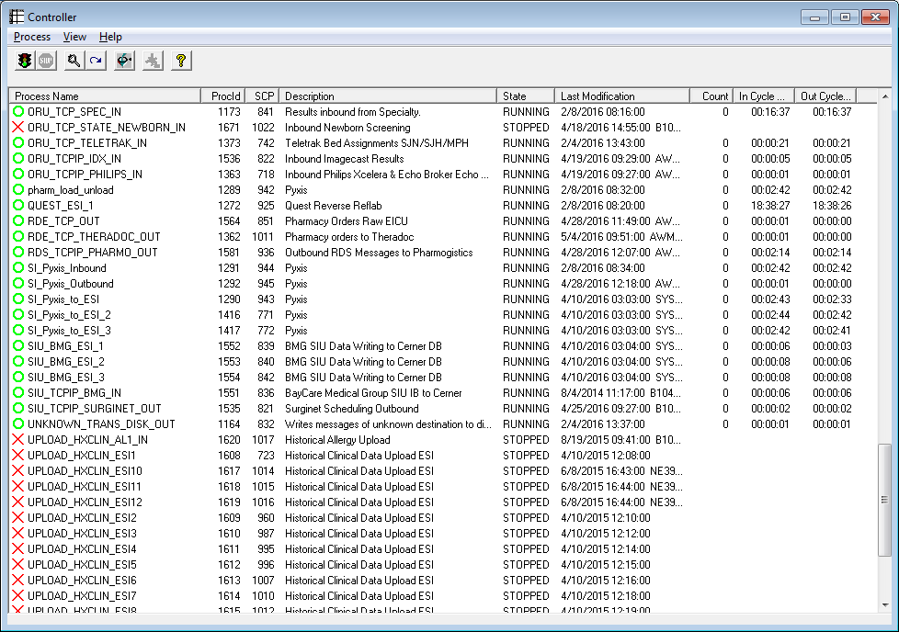

**M30**

Port Number: 19100

**P30**

Port Number: 19001

**Special Note:**

Mod Object Script, SPECIALTY_Trans_Format_v1, calls accession_rebuild.inc located in /cerner/d_p30/ccluserdir. If file, accession_rebuild.inc, is ***not*** found there then the mod object will ***not*** compile. If the com server crashes and msgview has the following error:

000045 04/26 08:47 err OenFormatterNoModObj OP_SPECIALTY_TRANS_FORMAT_V1

000044 04/26 08:47 err OENGeneric (FORMATTER:OBJECT_TO_OBJECT)"OP_SPECIALTY_TRANS_FORMAT_V1" failed!

000043 04/25 13:02 err OenErrorReport W2=C Interface shutting down.

000042 04/25 13:02 err OenErrorReport W2=C. Format Failure.. See Openview.hlp - Communication Step Errors for mo...

000041 04/25 13:02 err OENGeneric %CCL-E-43-SHRCCL(0,0)160425:1302{}Could not execute program (OP_SPECIALTY_TR...

msg> show 41

[cmb_0841]

entry: 41

date: 25 Apr 2016 13:02:20

user: n/a - [d_m30]

location: baycflapp7/86810/86833

source: SRV0841_0001_0/OEN.ComService.1173

sourceref:

event: OENGeneric

level: error

<text>

%CCL-E-43-SHRCCL(0,0)160425:1302{}Could not execute program (OP_SPECIALTY_TRANS_FORMAT_V1:0) since not found in object lib (Prot).

Then open an SR with Cerner to put the file accession_rebuild.inc back in /cerner/d_p30/ccluserdir. It requires root privileges. See SR 412590908 for additional details.

### 3.3.6 Outbound BayCare Cerner to Cloverleaf

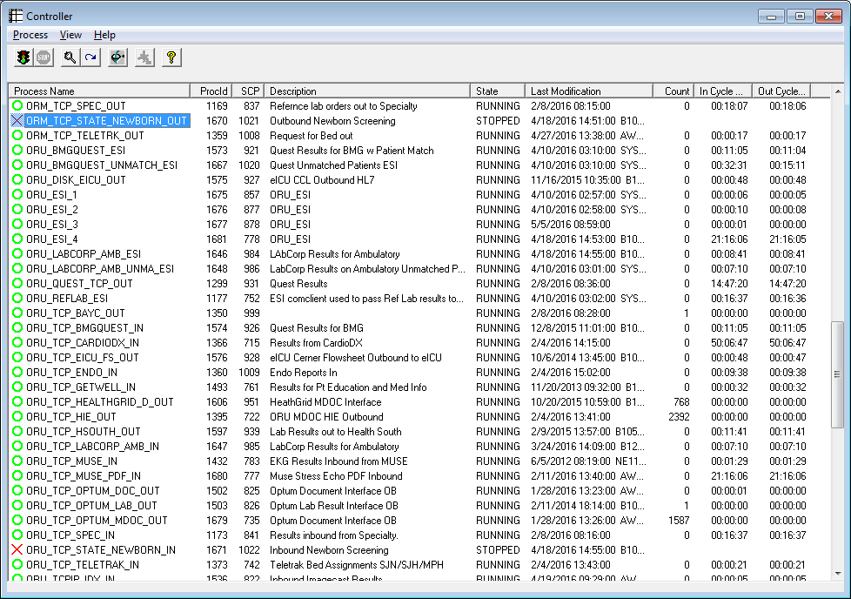

**M30**

Port Number: 19154

IP Address: 10.100.128.66 (note that this is a ***Natted IP*** to Cloverleaf Test 10.5.250.203)

**P30**

Port Number: 19050

IP Address: 10.100.128.64 (note that this is a ***Natted IP*** to Cloverleaf Prod 10.5.250.201)

**Special Notes:**

1. Based on the Lab build, FSI will take the Specialty tracking number, code value, and add it to the route script. This number is ***different*** per domain and can be found in the location alias maintenance tool. Expand Location views, expand specimen tracking and find desired facility, Bartow, for example. Right click on Bartow Specialty TRK and select display alias.
2. Core must configure the Cerner outbound facility alias in source SPECIALTY.
3. The Cerner facility alias must be added to Cloverleaf table, BCOUTRCH.
4. Reminder, this interface uses trigger, ORM Reference Lab with Type ***PKL*** = Package List *(as a route script qualification)* ***Note:*** BayCare takes the specimen and sends the order with the package list because it’s a special lab ***not*** done at BayCare. Quest will process and send the result to BayCare.

# 4. HL7 Messaging

## 4.1 Messaging Format

### 4.1.1 Segments

The segments utilized for the ORM interface are:

MSH

[

PID

PV1

{ORC}

[

{OBR}

[{NTE}]

]

The segments utilized for the ORU interface are:

MSH

PID

[PV1]

{

ORC

OBR

[{NTE}]

*Message Construction Notes:*

*[Square Brackets] – Optional*

*{Curly Brackets} – Repeatable*

*MSH – Message Header*

*EVN – Event segment*

*PID – Patient ID segment*

*PV1 – Patient Visit segment*

*ORC – Common Order segment*

*IN1 – Insurance segment*

*[{ – Start of optional, repeatable group*

*}] – End of optional, repeatable group*

### 4.1*.*2 Messaging Event Types

Below are the messages types necessary for this integration

|  |  |
| --- | --- |
| **Event Type** | **Description** |
| ORM^O01 | Order |
| ORU^R01 | Result |

### 4.1*.*3 Cloverleaf Configuration Files

For each HL7 interface specified in Section 2 of this document, identify the Cloverleaf Configuration Files: Variants, TCL Scripts, Xlates, etc.

cerner_specialty_orm

### 4.1.4 Cloverleaf Site Location

**Orders**

M30

SITE: **cerner_orders_6** & THREAD: **orm_cer_in_s_mck** , orm_spec_out_t

P30

SITE: **cerner_orders_6** & THREAD: **orm_cer_in_s, orm_spec_out**

## 4.2 Data Transformation Requirements

| **Field Description** | **HL7 Field Loc.** | **Required Y/N** | **Data Type** | **Length** | **Notes** |
| --- | --- | --- | --- | --- | --- |
| Sending Application | MSH-3 | Y |  |  | Hardcode CERNER LAB |
| Sending Facility | MSH-4 | Y |  |  | pass PV1-39 thru Table BCOUTREACH  IF BCOUTREACH copy PV1-18  Else  copy PV1-39 |
| Receiving Application | MSH-5 | Y |  |  | Hard code RUBICON |
| Receiving Facility | MSH-6 | Y |  |  | Hardcode ="SLI SM, CA" |
| Date/Time of message | MSH-7 |  |  |  | Copy |
| Version ID | MSH-12 |  |  |  | Hardcode 2.1 |
| PID Segment |  |  |  |  | Pathcopy |
| Order Control | ORC-1 | Y |  |  | Copy |
|  |  |  |  |  |  |
| Placer Order Number | ORC-2 | Y |  |  | Copy |
| Filler Order number | ORC-3 |  |  |  | Copy |
| Placer group Number | ORC-4 |  |  |  | Copy |
| Order status | ORC-5 |  |  |  | Copy |
| Ordering Provider | ORC-12 |  |  |  | Copy |
| Order Control Code reason | ORC-16 |  |  |  | Copy |
| OBR Segment |  |  |  |  | Pathcopy |
| Collection Volume | OBR-9 |  |  |  | Null Out |
| Placer field 1 | OBR-18 |  |  |  | Copy OBR-4 |
| Placer field 2 | OBR-19 |  |  |  | Copy OBR-20 |

## 4.3 Sample Messages

**Cerner**

**Outbound Cerner *Order*:**

MSH|^~\&|HNAM|BAYCARE|SPECIALTY|SPECIALTY|20160421121901||ORM^O01|Q2630762533T3249749921||2.3||||||8859/1

PID|1|2005000647^^^BayCare MRN|2005000647^^^BayCare MRN~800000669^^^BayCare CMRN||BARTOWTEST^TWO^^^^^CURRENT||19930303|M||||||||||1005000683^^^BayCare FIN|||||||0

PV1|1|I|^^^BRM^^Building(s)^BRM||||125^Cssxbb^Zxgdcz^K^Qg^^^^External Id^PERSONNEL^^^External Identifier~D50943^Cssxbb^Zxgdcz^K^Qg^^^^UPIN^PERSONNEL^^^DOCUPIN^CACTUS~679^Cssxbb^Zxgdcz^K^Qg^^^^MPH^PERSONNEL^^^ORGANIZATION DOCTOR^CACTUS~679^Cssxbb^Zxgdcz^K^Qg^^^^MDU^PERSONNEL^^^ORGANIZATION DOCTOR^CACTUS~679^Cssxbb^Zxgdcz^K^Qg^^^^NBY^PERSONNEL^^^ORGANIZATION DOCTOR^CACTUS~7001^Cssxbb^Zxgdcz^K^Qg^^^^SAH^PERSONNEL^^^ORGANIZATION DOCTOR^CACTUS~79636^Cssxbb^Zxgdcz^K^Qg^^^^SJH^PERSONNEL^^^ORGANIZATION DOCTOR^CACTUS~79636^Cssxbb^Zxgdcz^K^Qg^^^^SJW^PERSONNEL^^^ORGANIZATION DOCTOR^CACTUS~BA0725703^Cssxbb^Zxgdcz^K^Qg^^^^DEA No^PERSONNEL^^^DOCDEA^CACTUS~ME49317^Cssxbb^Zxgdcz^K^Qg^^^^Doctor License Number^PERSONNEL^^^LICENSENBR^CACTUS~1679582142^Cssxbb^Zxgdcz^K^Qg^^^^CD:34025052^PERSONNEL^^^CD:4040681^CACTUS~79636^Cssxbb^Zxgdcz^K^Qg^^^^CD:116096908^PERSONNEL^^^ORGANIZATION DOCTOR^CACTUS~MS004894^Cssxbb^Zxgdcz^K^Qg^^^^CD:228049736^PERSONNEL^^^CD:4040682^CACTUS~79636^Cssxbb^Zxgdcz^K^Qg^^^^SFB^PERSONNEL^^^ORGANIZATION DOCTOR^CACTUS~MS004894^Cssxbb^Zxgdcz^K^Qg^^^^BayCare Dr Number^PERSONNEL^^^ORGANIZATION DOCTOR^CACTUS~679^Cssxbb^Zxgdcz^K^Qg^^^^MCS^PERSONNEL^^^ORGANIZATION DOCTOR^CACTUS~79636^Cssxbb^Zxgdcz^K^Qg^^^^CD:1025606149^PERSONNEL^^^ORGANIZATION DOCTOR^CACTUS~004894^Cssxbb^Zxgdcz^K^Qg^^^^CD:1224392299^PERSONNEL^^^ORGANIZATION DOCTOR^CACTUS~004894^Cssxbb^Zxgdcz^K^Qg^^^^CD:1224388639^PERSONNEL^^^ORGANIZATION DOCTOR^CACTUS||||||||||125^Cssxbb^Zxgdcz^K^Qg^^^^External Id^PERSONNEL^^^External Identifier~D50943^Cssxbb^Zxgdcz^K^Qg^^^^UPIN^PERSONNEL^^^DOCUPIN^CACTUS~679^Cssxbb^Zxgdcz^K^Qg^^^^MPH^PERSONNEL^^^ORGANIZATION DOCTOR^CACTUS~679^Cssxbb^Zxgdcz^K^Qg^^^^MDU^PERSONNEL^^^ORGANIZATION DOCTOR^CACTUS~679^Cssxbb^Zxgdcz^K^Qg^^^^NBY^PERSONNEL^^^ORGANIZATION DOCTOR^CACTUS~7001^Cssxbb^Zxgdcz^K^Qg^^^^SAH^PERSONNEL^^^ORGANIZATION DOCTOR^CACTUS~79636^Cssxbb^Zxgdcz^K^Qg^^^^SJH^PERSONNEL^^^ORGANIZATION DOCTOR^CACTUS~79636^Cssxbb^Zxgdcz^K^Qg^^^^SJW^PERSONNEL^^^ORGANIZATION DOCTOR^CACTUS~BA0725703^Cssxbb^Zxgdcz^K^Qg^^^^DEA No^PERSONNEL^^^DOCDEA^CACTUS~ME49317^Cssxbb^Zxgdcz^K^Qg^^^^Doctor License Number^PERSONNEL^^^LICENSENBR^CACTUS~1679582142^Cssxbb^Zxgdcz^K^Qg^^^^CD:34025052^PERSONNEL^^^CD:4040681^CACTUS~79636^Cssxbb^Zxgdcz^K^Qg^^^^CD:116096908^PERSONNEL^^^ORGANIZATION DOCTOR^CACTUS~MS004894^Cssxbb^Zxgdcz^K^Qg^^^^CD:228049736^PERSONNEL^^^CD:4040682^CACTUS~79636^Cssxbb^Zxgdcz^K^Qg^^^^SFB^PERSONNEL^^^ORGANIZATION DOCTOR^CACTUS~MS004894^Cssxbb^Zxgdcz^K^Qg^^^^BayCare Dr Number^PERSONNEL^^^ORGANIZATION DOCTOR^CACTUS~679^Cssxbb^Zxgdcz^K^Qg^^^^MCS^PERSONNEL^^^ORGANIZATION DOCTOR^CACTUS~79636^Cssxbb^Zxgdcz^K^Qg^^^^CD:1025606149^PERSONNEL^^^ORGANIZATION DOCTOR^CACTUS~004894^Cssxbb^Zxgdcz^K^Qg^^^^CD:1224392299^PERSONNEL^^^ORGANIZATION DOCTOR^CACTUS~004894^Cssxbb^Zxgdcz^K^Qg^^^^CD:1224388639^PERSONNEL^^^ORGANIZATION DOCTOR^CACTUS|Inpatient|||||||||||||||||||||BRM||Active|||20160217220300

ORC|NW|7677806061^HNAM_ORDERID|||Ordered||||20160421121017|JED49308^Pxmuee^Qczub^U^^^^^External Id^PERSONNEL^^^External Identifier||125^Cssxbb^Zxgdcz^K^Qg^^^^External Id^PERSONNEL^^^External Identifier~D50943^Cssxbb^Zxgdcz^K^Qg^^^^UPIN^PERSONNEL^^^DOCUPIN^CACTUS~679^Cssxbb^Zxgdcz^K^Qg^^^^MPH^PERSONNEL^^^ORGANIZATION DOCTOR^CACTUS~679^Cssxbb^Zxgdcz^K^Qg^^^^MDU^PERSONNEL^^^ORGANIZATION DOCTOR^CACTUS~679^Cssxbb^Zxgdcz^K^Qg^^^^NBY^PERSONNEL^^^ORGANIZATION DOCTOR^CACTUS~7001^Cssxbb^Zxgdcz^K^Qg^^^^SAH^PERSONNEL^^^ORGANIZATION DOCTOR^CACTUS~79636^Cssxbb^Zxgdcz^K^Qg^^^^SJH^PERSONNEL^^^ORGANIZATION DOCTOR^CACTUS~79636^Cssxbb^Zxgdcz^K^Qg^^^^SJW^PERSONNEL^^^ORGANIZATION DOCTOR^CACTUS~BA0725703^Cssxbb^Zxgdcz^K^Qg^^^^DEA No^PERSONNEL^^^DOCDEA^CACTUS~ME49317^Cssxbb^Zxgdcz^K^Qg^^^^Doctor License Number^PERSONNEL^^^LICENSENBR^CACTUS~1679582142^Cssxbb^Zxgdcz^K^Qg^^^^CD:34025052^PERSONNEL^^^CD:4040681^CACTUS~79636^Cssxbb^Zxgdcz^K^Qg^^^^CD:116096908^PERSONNEL^^^ORGANIZATION DOCTOR^CACTUS~MS004894^Cssxbb^Zxgdcz^K^Qg^^^^CD:228049736^PERSONNEL^^^CD:4040682^CACTUS~79636^Cssxbb^Zxgdcz^K^Qg^^^^SFB^PERSONNEL^^^ORGANIZATION DOCTOR^CACTUS~MS004894^Cssxbb^Zxgdcz^K^Qg^^^^BayCare Dr Number^PERSONNEL^^^ORGANIZATION DOCTOR^CACTUS~679^Cssxbb^Zxgdcz^K^Qg^^^^MCS^PERSONNEL^^^ORGANIZATION DOCTOR^CACTUS~79636^Cssxbb^Zxgdcz^K^Qg^^^^CD:1025606149^PERSONNEL^^^ORGANIZATION DOCTOR^CACTUS~004894^Cssxbb^Zxgdcz^K^Qg^^^^CD:1224392299^PERSONNEL^^^ORGANIZATION DOCTOR^CACTUS~004894^Cssxbb^Zxgdcz^K^Qg^^^^CD:1224388639^PERSONNEL^^^ORGANIZATION DOCTOR^CACTUS|||20160421121019|||Written^Written/Paper/Fax|JED49308^Pxmuee^Qczub^U^^^^^External Id^PERSONNEL^^^External Identifier

OBR|1|7677806061^HNAM_ORDERID||Z1392^ALDOLASE|||20160420120500||||O|||20160421121700|Blood&Blood|125^Cssxbb^Zxgdcz^K^Qg^^^^External Id^PERSONNEL^^^External Identifier~D50943^Cssxbb^Zxgdcz^K^Qg^^^^UPIN^PERSONNEL^^^DOCUPIN^CACTUS~679^Cssxbb^Zxgdcz^K^Qg^^^^MPH^PERSONNEL^^^ORGANIZATION DOCTOR^CACTUS~679^Cssxbb^Zxgdcz^K^Qg^^^^MDU^PERSONNEL^^^ORGANIZATION DOCTOR^CACTUS~679^Cssxbb^Zxgdcz^K^Qg^^^^NBY^PERSONNEL^^^ORGANIZATION DOCTOR^CACTUS~7001^Cssxbb^Zxgdcz^K^Qg^^^^SAH^PERSONNEL^^^ORGANIZATION DOCTOR^CACTUS~79636^Cssxbb^Zxgdcz^K^Qg^^^^SJH^PERSONNEL^^^ORGANIZATION DOCTOR^CACTUS~79636^Cssxbb^Zxgdcz^K^Qg^^^^SJW^PERSONNEL^^^ORGANIZATION DOCTOR^CACTUS~BA0725703^Cssxbb^Zxgdcz^K^Qg^^^^DEA No^PERSONNEL^^^DOCDEA^CACTUS~ME49317^Cssxbb^Zxgdcz^K^Qg^^^^Doctor License Number^PERSONNEL^^^LICENSENBR^CACTUS~1679582142^Cssxbb^Zxgdcz^K^Qg^^^^CD:34025052^PERSONNEL^^^CD:4040681^CACTUS~79636^Cssxbb^Zxgdcz^K^Qg^^^^CD:116096908^PERSONNEL^^^ORGANIZATION DOCTOR^CACTUS~MS004894^Cssxbb^Zxgdcz^K^Qg^^^^CD:228049736^PERSONNEL^^^CD:4040682^CACTUS~79636^Cssxbb^Zxgdcz^K^Qg^^^^SFB^PERSONNEL^^^ORGANIZATION DOCTOR^CACTUS~MS004894^Cssxbb^Zxgdcz^K^Qg^^^^BayCare Dr Number^PERSONNEL^^^ORGANIZATION DOCTOR^CACTUS~679^Cssxbb^Zxgdcz^K^Qg^^^^MCS^PERSONNEL^^^ORGANIZATION DOCTOR^CACTUS~79636^Cssxbb^Zxgdcz^K^Qg^^^^CD:1025606149^PERSONNEL^^^ORGANIZATION DOCTOR^CACTUS~004894^Cssxbb^Zxgdcz^K^Qg^^^^CD:1224392299^PERSONNEL^^^ORGANIZATION DOCTOR^CACTUS~004894^Cssxbb^Zxgdcz^K^Qg^^^^CD:1224388639^PERSONNEL^^^ORGANIZATION DOCTOR^CACTUS||||**000002016111000491**^HNA_ACCN~55059457^HNA_ACCNID||20160421121018||GENERAL LAB|||1^^0^20160420120550^^RT~^^^^^RT - ROUTINE|||||||||20160420120500

ORC|NW|7677806063^HNAM_ORDERID|||Ordered||||20160421121017|JED49308^Pxmuee^Qczub^U^^^^^External Id^PERSONNEL^^^External Identifier||125^Cssxbb^Zxgdcz^K^Qg^^^^External Id^PERSONNEL^^^External Identifier~D50943^Cssxbb^Zxgdcz^K^Qg^^^^UPIN^PERSONNEL^^^DOCUPIN^CACTUS~679^Cssxbb^Zxgdcz^K^Qg^^^^MPH^PERSONNEL^^^ORGANIZATION DOCTOR^CACTUS~679^Cssxbb^Zxgdcz^K^Qg^^^^MDU^PERSONNEL^^^ORGANIZATION DOCTOR^CACTUS~679^Cssxbb^Zxgdcz^K^Qg^^^^NBY^PERSONNEL^^^ORGANIZATION DOCTOR^CACTUS~7001^Cssxbb^Zxgdcz^K^Qg^^^^SAH^PERSONNEL^^^ORGANIZATION DOCTOR^CACTUS~79636^Cssxbb^Zxgdcz^K^Qg^^^^SJH^PERSONNEL^^^ORGANIZATION DOCTOR^CACTUS~79636^Cssxbb^Zxgdcz^K^Qg^^^^SJW^PERSONNEL^^^ORGANIZATION DOCTOR^CACTUS~BA0725703^Cssxbb^Zxgdcz^K^Qg^^^^DEA No^PERSONNEL^^^DOCDEA^CACTUS~ME49317^Cssxbb^Zxgdcz^K^Qg^^^^Doctor License Number^PERSONNEL^^^LICENSENBR^CACTUS~1679582142^Cssxbb^Zxgdcz^K^Qg^^^^CD:34025052^PERSONNEL^^^CD:4040681^CACTUS~79636^Cssxbb^Zxgdcz^K^Qg^^^^CD:116096908^PERSONNEL^^^ORGANIZATION DOCTOR^CACTUS~MS004894^Cssxbb^Zxgdcz^K^Qg^^^^CD:228049736^PERSONNEL^^^CD:4040682^CACTUS~79636^Cssxbb^Zxgdcz^K^Qg^^^^SFB^PERSONNEL^^^ORGANIZATION DOCTOR^CACTUS~MS004894^Cssxbb^Zxgdcz^K^Qg^^^^BayCare Dr Number^PERSONNEL^^^ORGANIZATION DOCTOR^CACTUS~679^Cssxbb^Zxgdcz^K^Qg^^^^MCS^PERSONNEL^^^ORGANIZATION DOCTOR^CACTUS~79636^Cssxbb^Zxgdcz^K^Qg^^^^CD:1025606149^PERSONNEL^^^ORGANIZATION DOCTOR^CACTUS~004894^Cssxbb^Zxgdcz^K^Qg^^^^CD:1224392299^PERSONNEL^^^ORGANIZATION DOCTOR^CACTUS~004894^Cssxbb^Zxgdcz^K^Qg^^^^CD:1224388639^PERSONNEL^^^ORGANIZATION DOCTOR^CACTUS|||20160421121020|||Written^Written/Paper/Fax|JED49308^Pxmuee^Qczub^U^^^^^External Id^PERSONNEL^^^External Identifier

OBR|1|7677806063^HNAM_ORDERID||Z4875W^SELENIUM|||20160420120500||||O|||20160421121700|Blood&Blood|125^Cssxbb^Zxgdcz^K^Qg^^^^External Id^PERSONNEL^^^External Identifier~D50943^Cssxbb^Zxgdcz^K^Qg^^^^UPIN^PERSONNEL^^^DOCUPIN^CACTUS~679^Cssxbb^Zxgdcz^K^Qg^^^^MPH^PERSONNEL^^^ORGANIZATION DOCTOR^CACTUS~679^Cssxbb^Zxgdcz^K^Qg^^^^MDU^PERSONNEL^^^ORGANIZATION DOCTOR^CACTUS~679^Cssxbb^Zxgdcz^K^Qg^^^^NBY^PERSONNEL^^^ORGANIZATION DOCTOR^CACTUS~7001^Cssxbb^Zxgdcz^K^Qg^^^^SAH^PERSONNEL^^^ORGANIZATION DOCTOR^CACTUS~79636^Cssxbb^Zxgdcz^K^Qg^^^^SJH^PERSONNEL^^^ORGANIZATION DOCTOR^CACTUS~79636^Cssxbb^Zxgdcz^K^Qg^^^^SJW^PERSONNEL^^^ORGANIZATION DOCTOR^CACTUS~BA0725703^Cssxbb^Zxgdcz^K^Qg^^^^DEA No^PERSONNEL^^^DOCDEA^CACTUS~ME49317^Cssxbb^Zxgdcz^K^Qg^^^^Doctor License Number^PERSONNEL^^^LICENSENBR^CACTUS~1679582142^Cssxbb^Zxgdcz^K^Qg^^^^CD:34025052^PERSONNEL^^^CD:4040681^CACTUS~79636^Cssxbb^Zxgdcz^K^Qg^^^^CD:116096908^PERSONNEL^^^ORGANIZATION DOCTOR^CACTUS~MS004894^Cssxbb^Zxgdcz^K^Qg^^^^CD:228049736^PERSONNEL^^^CD:4040682^CACTUS~79636^Cssxbb^Zxgdcz^K^Qg^^^^SFB^PERSONNEL^^^ORGANIZATION DOCTOR^CACTUS~MS004894^Cssxbb^Zxgdcz^K^Qg^^^^BayCare Dr Number^PERSONNEL^^^ORGANIZATION DOCTOR^CACTUS~679^Cssxbb^Zxgdcz^K^Qg^^^^MCS^PERSONNEL^^^ORGANIZATION DOCTOR^CACTUS~79636^Cssxbb^Zxgdcz^K^Qg^^^^CD:1025606149^PERSONNEL^^^ORGANIZATION DOCTOR^CACTUS~004894^Cssxbb^Zxgdcz^K^Qg^^^^CD:1224392299^PERSONNEL^^^ORGANIZATION DOCTOR^CACTUS~004894^Cssxbb^Zxgdcz^K^Qg^^^^CD:1224388639^PERSONNEL^^^ORGANIZATION DOCTOR^CACTUS||||**000002016111000491**^HNA_ACCN~55059457^HNA_ACCNID||20160421121019||GENERAL LAB|||1^^0^20160420120550^^RT~^^^^^RT - ROUTINE|||||||||20160420120500

**BCOUTREACH table**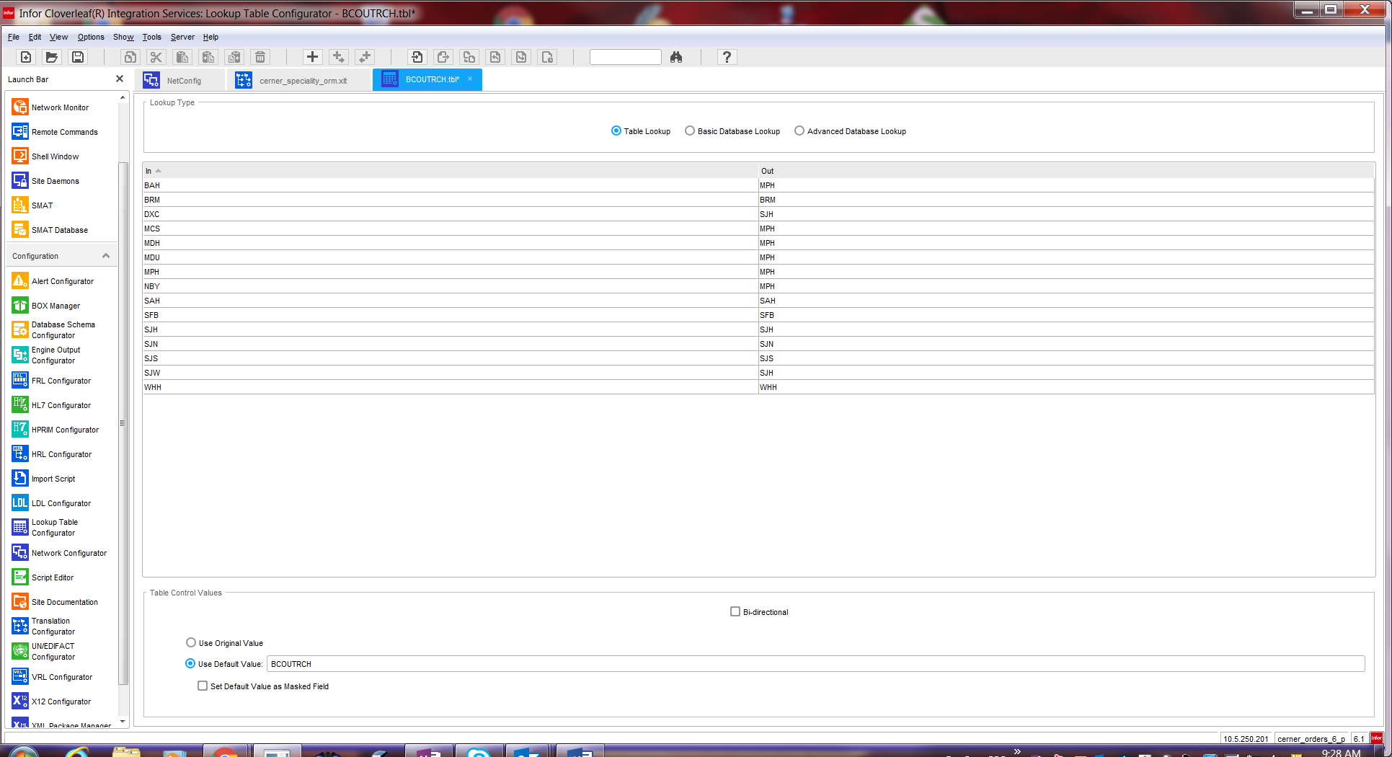

# **5. Testing**

## 5.1. Unit Testing Scenarios

Please see Monica Bousbar in the Lab

|  |  |
| --- | --- |
| **Scenario** | **Expected Result** |
|  |  |
|  |  |
|  |  |

## 5.2 Integrated Testing Scenarios

Please see Monica Bousbar in the Lab

|  |  |
| --- | --- |
| **Scenario** | **Expected Result** |
|  |  |
|  |  |
|  |  |

## 5.3 Testing Approvals

Please see Monica Bousbar in the Lab

|  |  |  |  |
| --- | --- | --- | --- |
| **Testing Phase** | **Date** | **Department** | **Team Member** |
| PH1.UNIT |  |  |  |
| PH1.INTEGRATED |  |  |  |
|  |  |  |  |

Per 5/4/2016 email:

I don’t need additional testing.

Thanks.

**Monica Bousbar**

Supervisor Clinical Systems/

Lab-I.S/Cerner PathNet

Office (727) 394-6492 |

**From:** Hatzopoulos, Ann M [<mailto:Ann.M.Hatzopoulos@questdiagnostics.com>]   
**Sent:** Wednesday, May 04, 2016 4:02 PM  
**To:** Dowell, Janet; Thies, Sarah B.; Bousbar, Monica; Kaczmarczyk, Hope E.; Buterbaugh, Donna; Allison, Richard C.  
**Cc:** Wentz, Jackie L  
**Subject:** RE: M30 Testing for BRM Quest Specialty Labs

I never received a response from anyone.  Is there any other testing that you would like to do on the new account?

Ann M. Hatzopoulos

Implementation Analyst

**Quest Diagnostics**| **Action from Insight**| 27027 Tourney Rd. | Valencia, CA 91355 USA | **phone**661.799.6633 | **fax** 661.799.6847 | [Ann.M.Hatzopoulos@QuestDiagnostics.com](mailto:Ann.M.Hatzopoulos@QuestDiagnostics.com) | [QuestDiagnostics.com](https://urldefense.proofpoint.com/v2/url?u=http-3A__questdiagnostics.com_&d=CwMFAg&c=MS-5dKql6qjhmD6zBX8NdQ&r=2APL3fJ7sMCKR58lu9jPLkj_QxxwbHSloPkALOQS1p8&m=4JlED-U2tywb-2JFNPp33yZIsm7_tPzNNp-xnJlZTkE&s=FaZ7RcQJ4Uq0QqnEGlqMqLrLw9eUqzYwsMEC_VzJCkM&e=)

## 5.4 Piloting

NA

## 5.5 Approvals - Please see Monica Bousbar in the Lab

|  |  |  |  |
| --- | --- | --- | --- |
| **Testing Phase** | **Date** | **Department** | **Team Member** |
| PH1.0 |  |  |  |
|  |  |  |  |
|  |  |  |  |

# 6. Deployment / Implementation Model

Provide the detail as to how to deploy the solution defined in the IDBB from both the BAYCARE and vendor perspective.

This change was implemented when Bartow Regional Hospital was added to the BayCare Health System. **CAB # 11022**

# Appendix A: Risks and Concerns

|  |  |  |  |  |  |  |  |  |
| --- | --- | --- | --- | --- | --- | --- | --- | --- |
| **Project Name** |  |  | | |  |  |  |  |
| **Number** | **Risk / Concern** | **Comment** | **Mitigation** | | |  |  |  |
| RC.2013.1.0 |  |  | |  | |  |  |  |

# Appendix B: Issues List

This is a dynamic list of the open issues related to the IDBB that remain to be solved, including but not limited to TBDs, pending decisions, information needed, conflict awaiting resolution, and the like.

|  |  |  |  |  |  |  |  |  |
| --- | --- | --- | --- | --- | --- | --- | --- | --- |
| **Project Name** |  |  | | |  |  |  |  |
| **Number** | **Issue** | **Comment** | **Fix** | | |  |  |  |
| I.2013.1.0 |  |  | |  | |  |  |  |

* End of document